# **Lab 02**

# **Introduction to Packet Tracer and IP Routing**

|  |  |
| --- | --- |
| **Name: Syed Asghar Abbas Zaidi** | **Student ID: 07201** |

## **2.1 Objective**

The Objectives of this lab are:

* Implementing static routing with a two-router configuration.
* Implementing static routing with a three-router configuration.
* Implementing dynamic routing using OSPF.

**2.2 Background/Scenario**

In computer networks, routing is the process of selecting paths for traffic in a network or between or across multiple networks. Understanding how to effectively manage and control this process is crucial for network administrators. There are two primary methods of routing: static routing and dynamic routing.

**Static Routing** is a method where the network administrator manually enters routes into the routing table. These routes do not change unless they are manually updated by the administrator. Static routing is straightforward and can be more secure since it doesn’t rely on external protocols to manage routes. However, it lacks scalability and flexibility, making it suitable for small or simple networks where the network topology is unlikely to change frequently.

**Dynamic Routing,** on the other hand, uses routing protocols to automatically discover and update routes in the routing table. Protocols like OSPF (Open Shortest Path First) enable routers to communicate with each other, share information about network topology, and automatically adjust to changes, such as link failures or changes in the network structure. Dynamic routing is essential for larger, more complex networks where manual updates would be impractical.

In this lab, you will explore both static and dynamic routing, understanding how to configure them,

**Topology**

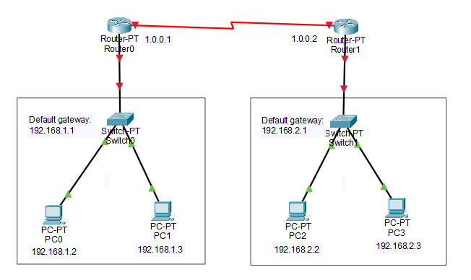Figure 1

**Addressing Table**

|  |  |  |  |  |  |
| --- | --- | --- | --- | --- | --- |
| **Device** | **Interface** | **IP Address** | **Subnet Mask** | **Default Gateway** | **Switch Port** |
| R1 | Se2/0 | 1.0.0.1 | 255.255.255.0 | N/A | N/A |
| FastEthernet0/0 | 192.168.1.1 | 255.255.255.0 | N/A | S0 F0/1 |
| R2 | Serial2/0 | 1.0.0.2 | 255.255.255.0 | N/A | N/A |
| FastEthernet0/0 | 192.168.2.1 | 255.255.255.0 | N/A | S1 F0/1 |
| PC-A | NIC | 192.168.1.2 | 255.255.255.0 | 192.168.1.1 | S1 F1/1 |
| PC-B | NIC | 192.168.1.3 | 255.255.255.0 | 192.168.1.1 | S1 F2/1 |
| PC-C | NIC | 192.168.2.2 | 255.255.255.0 | 192.168.2.1 | S2 F1/1 |
| PC-D | NIC | 192.168.2.3 | 255.255.255.0 | 192.168.2.1 | S1 F2/1 |

Table 1: IP addressing table

**Task 1: Implementing Static Routing in a Two-Router Configuration**

1. Construct the topology shown above
2. Configure the PCs with the IP addresses and subnet masks according to the IP address table given above
   1. To assign an IP address to a PC, click on the PC, go to Desktop and then IP configuration. Fill up the IP address and subnet mask.

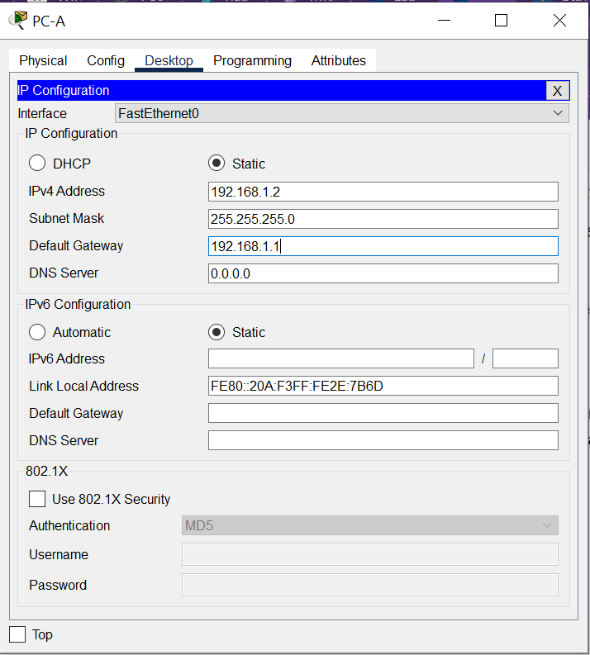Figure 2

* 1. Alternatively, you can also use the ipconfig command in the PC terminal

ipconfig <IPv4 address><subnet mask><default gateway>

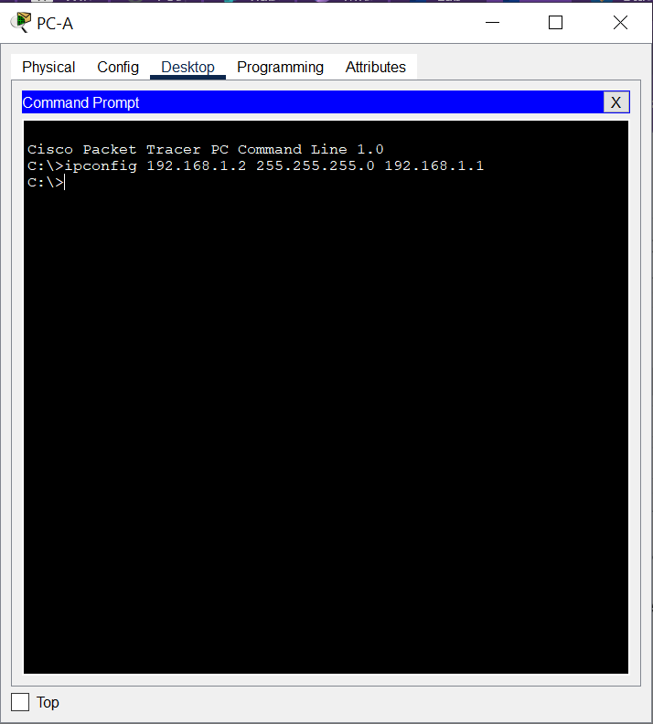

Figure 3

1. Configure routers with IP addresses and subnet masks
   1. To assign an IP address to a router, go to the router’s config tab and then interfaces. Configure the IP address in Fastethernet and Serial ports according to Table 1.

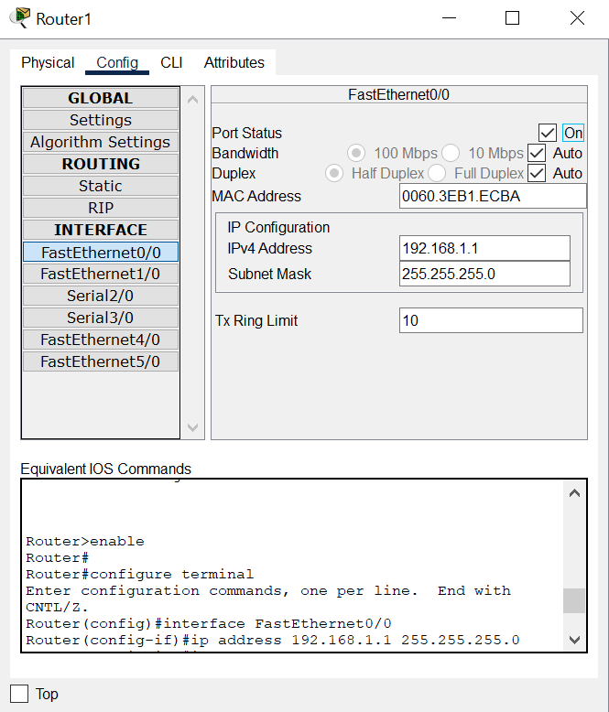Figure 4

1. Assign routes to the routers
   1. Go to the router’s CLI, then type the following commands

Ip route <network id><subnet mask> <next hop>

Static route for Router1:

Router(config-if)#ip route 192.168.2.0 255.255.255.0 1.0.0.2

Static route for Router2:

Router(config-if)#ip route 192.168.1.0 255.255.255.0 1.0.0.1

1. Verify the network by pinging the IP address of any PC.
   1. Click on PC, then go to the command prompt
   2. Type ‘ping <ip address of targeted node>’

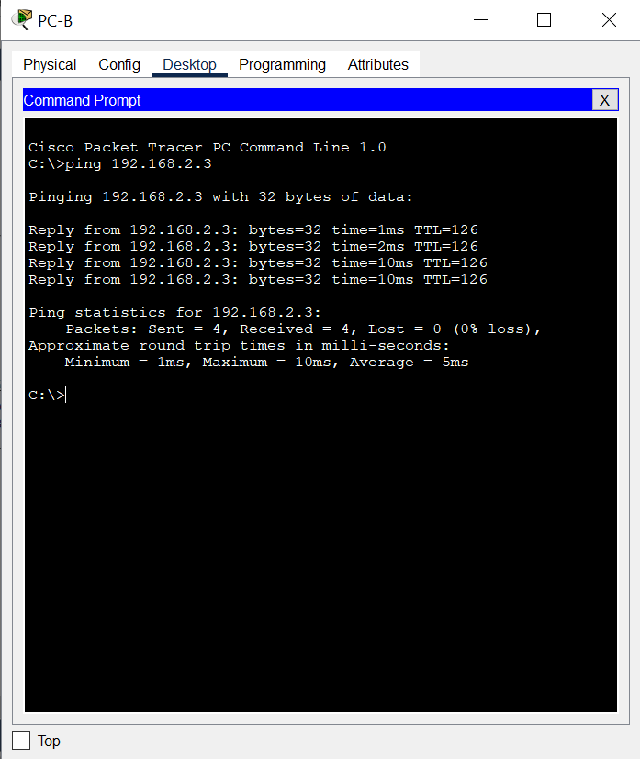Figure 5

|  |
| --- |
| Pinging from PC0 to Default Gateway (first router), second router, PC1 (on the same network) and PC2 (on other network)    Pinging to PC3 (same network), then to default gateway (Router 2 within the same network), then Router 1 (different network) and PC0 in different network    **Router1 configuation:**        So you assign the default gateway port its’ own ip address and same with the other port which is getting connected with the other router. Now, 192.168.2.0 network is connected through 1.0.0.2. Router 0 knows of 1.0.0.2 cause it is connected to it. But what it doesn’t know is what other network lies ahead of that router so you need to tell that either by telling it statically or dynamically (through OSPF)  **Router2 configuration:**        **Topology Configuration:** |

**Topology**

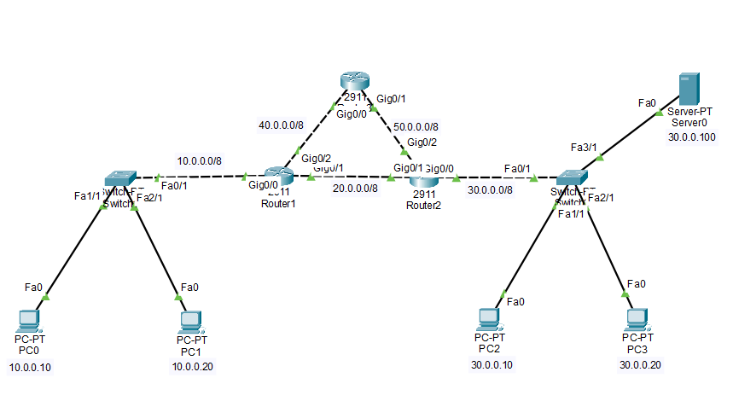Figure 6

**Addressing Table**

|  |  |  |  |  |  |
| --- | --- | --- | --- | --- | --- |
| **Device** | **Interface** | **IP Address** | **Subnet Mask** | **Default Gateway** | **Switch Port** |
| R1 | G0/0 | 10.0.0.1 | 255.0.0.0 | N/A | S0 F0/1 |
| G0/1 | 20.0.0.1 | 255.0.0.0 | N/A | N/A |
| G0/2 | 40.0.0.1 | 255.0.0.0 | N/A | N/A |
| R2 | G0/0 | 30.0.0.1 | 255.0.0.0 | N/A | S1 F0/1 |
| G0/1 | 20.0.0.1 | 255.0.0.0 | N/A | N/A |
| G0/2 | 50.0.0.1 | 255.0.0.0 | N/A | N/A |
| R3 | G0/0 | 40.0.0.2 | 255.0.0.0 | N/A | N/A |
| G0/1 | 50.0.0.1 | 255.0.0.0 | N/A | N/A |
| PC-1 | NIC | 10.0.0.10 | 255.0.0.0 | 10.0.0.1 | S1 F1/1 |
| PC-2 | NIC | 10.0.0.20 | 255.0.0.0 | 10.0.0.1 | S1 F2/1 |
| PC-3 | NIC | 30.0.0.10 | 255.0.0.0 | 30.0.0.1 | S2 F1/1 |
| PC-4 | NIC | 30.0.0.20 | 255.0.0.0 | 30.0.0.1 | S2 F2/1 |
| Server-S0 | NIC | 30.0.0.100 | 255.0.0.0 | 30.0.0.1 | S2 F3/1 |

Table 2

**Task 2: Implementing Static Routing in a Three-Router Configuration**

1. Construct the topology shown in Figure 6.

|  |
| --- |
|  |

1. Assign IP addresses, subnet masks and default gateway addresses according to Table 2.
2. Configure static routing on router 1,
   1. Create two routes for network 30.0.0.0/8 and configure the first route (via -Router2) as the main route and the second route (via-Router3) as a backup route.

|  |
| --- |
|  |

* 1. Create two routes for the host 30.0.0.100/8 and configure the first route (via -Router3) as the main route and the second route (via-Router2) as a backup route.

|  |
| --- |
| It belongs to the same network as 30.0.0.0 as its’ subnet mask is /8, so it will use the same route as statically given in a) |

* 1. Create two routes for network 50.0.0.0/8 and configure the first route (via -Router3) as the main route and the second route (via-Router2) as a backup route.

|  |
| --- |
|  |

1. Configure static routing on router 2,
   1. Create two routes for network 10.0.0.0/8 and configure the first route (via -Router1) as the main route and the second route (via-Router2) as a backup route.
   2. Create two routes for network 40.0.0.0/8 and configure the first route (via -Router1) as the main route and the second route (via-Router3) as a backup route.
   3. Verify the router adds only main routes to the routing table using the “show ip route static” command.

|  |
| --- |
| a)    b)    C)    Extra) |

1. Create static routes for network 10.0.0.0/8 and network 30.0.0.0/8 and verify the router adds both routes to the routing table.

|  |
| --- |
| I am assuming this is referring to the configuration of router 3    Verification: |

1. On Router1, we configured two routes for network 30.0.0.0/8. These routes are via Router2 and via Router3. We set the first route (via-Router2) as the main route and the second route as the backup route. We can verify this configuration in two ways.

* By sending ping requests to a PC of network 30.0.0.0/8 and tracing the path they take to reach the network 30.0.0.0/8. For this, you can use **'tracert'** command on a PC of network 10.0.0.0/8. The **'tracert'** command sends ping requests to the destination host and tracks the path they take to reach the destination.
* By listing the routing table entries on Router0. Since a router uses the routing table to forward data packets, you can check the routing table to figure out the route the router uses to forward data packets for each destination.

Verify static routing by using the **tracert** command on PC1 to ping Server S0.

|  |
| --- |
| Using the backup route |

1. Use the **tracert** command on PC1 to trace the route taken by a packet sent to PC3

|  |
| --- |
| **Using the backup route:** |

### **Topology**

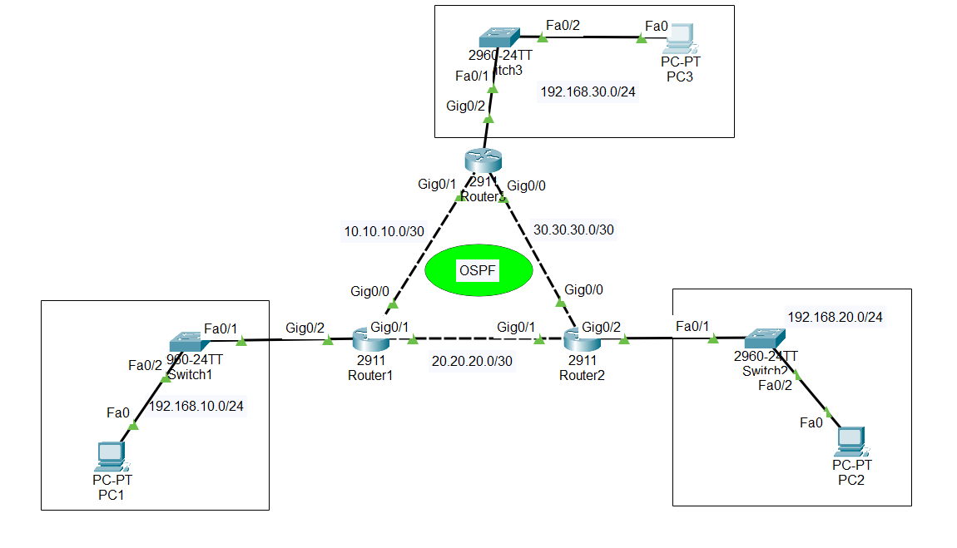.Figure 7

**Addressing Table**

|  |  |  |  |  |  |
| --- | --- | --- | --- | --- | --- |
| **Device** | **Interface** | **IP Address** | **Subnet Mask** | **Default Gateway** | **Switch Port** |
| R1 | G0/0 | 10.10.10.1 | 255.255.255.252 | N/A | N/A |
| G0/1 | 20.20.20.1 | 255.255.255.252 | N/A | N/A |
| G0/2 | 192.168.10.1 | 255.255.255.0 | N/A | S1 F0/1 |
| R2 | G0/0 | 30.30.30.1 | 255.255.255.252 | N/A | N/A |
| G0/1 | 20.20.20.2 | 255.255.255.252 | N/A | N/A |
| G0/2 | 192.168.20.1 | 255.255.255.0 | N/A | S2 F0/1 |
| R3 | G0/0 | 30.30.30.2 | 255.255.255.252 | N/A | N/A |
| G0/1 | 10.10.10.2 | 255.255.255.252 | N/A | N/A |
| G0/2 | 192.168.30.1 | 255.255.255.0 | N/A | S3 F0/1 |
| PC-1 | NIC | 192.168.10.10 | 255.255.255.0 | 192.168.10.1 | S1 F0/2 |
| PC-2 | NIC | 192.168.20.10 | 255.255.255.0 | 192.168.20.1 | S2 F0/2 |
| PC-3 | NIC | 192.168.30.10 | 255.255.255.0 | 192.168.30.1 | S3 F0/2 |

Table 3

**Task 3: Configuring OSPF for Dynamic Routing**

**Open Shortest Path First (OSPF)** is a link-state routing protocol used to manage IP routing within an autonomous system. It operates by having routers exchange information about the state of their network links to build a comprehensive map of the network topology.

1. Construct the topology shown in Fig 7.

|  |
| --- |
|  |

1. Assign addresses according to Table 3. Ensure each device is configured correctly with the assigned IP address and subnet mask.
2. Enable OSPF routing on router 1 in global configuration mode by using the command below.

Router(config)# router ospf [process_ID]

The process_ID is a unique identifier for the OSPF process on this router, and it can be any number from 1 to 65,535. Note that the process_ID does not need to match across different routers, as it is locally significant to each router.

1. Assign an area to the interface

Router(config-router)# network IP_network_# [wildcard_mask] area [area number]

This command enables OSPF on the interface if the IP address matches the specified network. The wildcard_mask is used to identify which parts of the IP address to match, where a 0 indicates a matching bit and a 1 indicates an ignoring bit. For example, a wildcard mask of 0.255.255.255 will match only the first byte of the network address.

The area_number specifies the OSPF area that the interface will be part of. It can range from 0 to 4,294,967,295. OSPF areas are used to manage and limit the routing information shared between routers. Detailed routing information is shared only within the same OSPF area, while summarized information is shared between different OSPF areas. Note that Area 0 is the backbone area, and all other OSPF areas must connect to it.

1. Next, configure OSPF on router 1 to advertise the connected networks. The configuration for Router 1 is shown below.

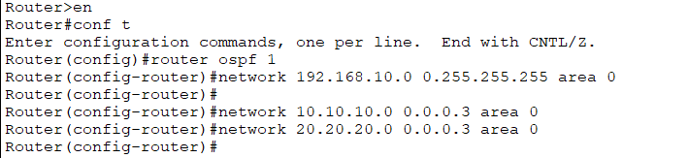

|  |
| --- |
|  |

1. Repeat steps 3-5 for Router 2 and 3.

Router 2:

|  |
| --- |
|  |

Router 3:

|  |
| --- |
|  |

1. After configuring OSPF on all routers, verify the configuration by checking the OSPF routing table using the **show ip route ospf** command and neighbor status using **show ip ospf neighbor**

|  |
| --- |
| **Router 1:**    **Router 2:**    **Router 3:** |

1. Ping from one end device to another across the network to ensure OSPF is routing traffic correctly.

|  |
| --- |
| All:      PC0 (192.168.10.2) to PC3 (192.168.20.2)  : |

What if now, an unauthorized router starts flooding your network with false advertisements, threatening its stability? In our next lab, we’ll tackle this issue by setting up OSPF authentication to secure our network.

|  |
| --- |
| When unauthorized routers flood an OSPF network with false advertisements, it can severely impact network stability and functionality. The primary issue is **routing table pollution**, where incorrect routing information is introduced, causing legitimate routes to be replaced with invalid ones. This misrouting of traffic can lead to network segments becoming unreachable and degrade overall network performance.  Additionally, the influx of false advertisements can strain router resources, leading to **increased CPU and memory usage**. This overloading can affect the routers' ability to process legitimate routing operations efficiently. The network might also experience instability due to routing loops, where packets endlessly circulate between routers, further disrupting network connectivity.  **False advertisements can also slow down network convergence**—the process by which routers update their routing tables to reflect network changes. This delay prolongs the time it takes for the network to stabilize after changes. Moreover, the presence of unauthorized routers poses security risks, as they could potentially exploit their position to intercept or manipulate traffic, leading to data breaches or other security threats.  In essence, **false OSPF advertisements can disrupt routing, overburden network resources, introduce instability, and pose security risks**, making it essential to implement strong security measures like authentication, route filtering, and vigilant network management. |

## **Assessment Rubric**

**Lab 02**

**Introduction to Packet Tracer and IP Routing**

|  |  |
| --- | --- |
| **Name: Syed Asghar Abbas Zaidi** | **Student ID: 07201** |

**Points Distribution**

|  |  |  |
| --- | --- | --- |
| **Task No.** | **LR 2**  **Simulation** | **LR9**  **Report** |
| Task 1 | 20 |  |
| Task 2 | 30 |  |
| Task 3 | 30 |  |
| Total | /80 | /20 |
| **CLO Mapped** | CLO 1 | CLO1 |
|  |  |  |

|  |  |  |  |
| --- | --- | --- | --- |
| **Affective Domain Rubric** | | **Points** | **CLO Mapped** |
| AR 7 | Report Submission | /20 | CLO 1 |

|  |  |  |
| --- | --- | --- |
| **CLO** | **Total Points** | **Points Obtained** |
| 1 | 100 |  |
| **Total** | **100** |  |

*For description of different levels of the mapped rubrics, please refer the provided Lab Evaluation Assessment Rubrics and Affective Domain Assessment Rubrics.*

**Lab Evaluation Assessment Rubric**

|  |  |  |  |  |  |
| --- | --- | --- | --- | --- | --- |
| **#** | **Assessment Elements** | **Level 1: Unsatisfactory**  **Points 0-1** | **Level 2: Developing**  **Points 2** | **Level 3:Good**  **Points 3** | **Level 4:Exemplary**  **Points 4** |
| **LR2** | **Program/Code/ Simulation Model/ Network Model** | Program/code/simulation model/network model does not implement the required functionality and has several errors. The student is not able to utilize even the basic tools of the software. | Program/code/simulation model/network model has some errors and does not produce completely accurate results. Student has limited command on the basic tools of the software. | Program/code/simulation model/network model gives correct output but not efficiently implemented or implemented by computationally complex routine. | Program/code/simulation /network model is efficiently implemented and gives correct output. Student has full command on the basic tools of the software. |
| **LR5** | **Results & Plots** | Figures/ graphs / tables are not developed or are poorly constructed with erroneous results. Titles, captions, units are not mentioned. Data is presented in an obscure manner. | Figures, graphs and tables are drawn but contain errors. Titles, captions, units are not accurate. Data presentation is not too clear. | All figures, graphs, tables are correctly drawn but contain minor errors or some of the details are missing. | Figures / graphs / tables are correctly drawn and appropriate titles/captions and proper units are mentioned. Data presentation is systematic. |
| **LR9** | **Report** | All the in-lab tasks are not included in report and / or the report is submitted too late. | Most of the tasks are included in report but are not well explained. All the necessary figures / plots are not included. Report is submitted after due date. | Good summary of most the in-lab tasks is included in report. The work is supported by figures and plots with explanations. The report is submitted timely. | Detailed summary of the in-lab tasks is provided. All tasks are included and explained well. Data is presented clearly including all the necessary figures, plots and tables. |